Dalton Murray

Systems Analysis and Design

INT 6123 – Systems Analysis and Design

Dr. Andrew Makar

November 19, 2023

**IA #11 Spring Breaks R Us**

**Question 4 – Once those decisions are made, develop a project iteration plan. If you have multiple independent teams, your project iteration plan will have parallel paths.**

(*As a note, the book shows a project iteration plan similar to what I created in case study 10 question 3, it also does not mention iteration plans outside of a few times, given that the assignment on Canvas says “Develop the project schedule using Microsoft Project or Gantter.com” and none of the actual questions say to do this, I will make up a gantt chart/project schedule for it despite the book not actually showing this as a iteration plan)

I will be creating the project schedule/iteration plan using 3 teams. The first team is 2 people, the second team is 1 person, and the third team is 1 person.

*Please note, in exporting the visual/image/timeline appears slightly in the wrong order/sorting by ID fixes this, but when exporting it defaults to a different sort.

PNG:

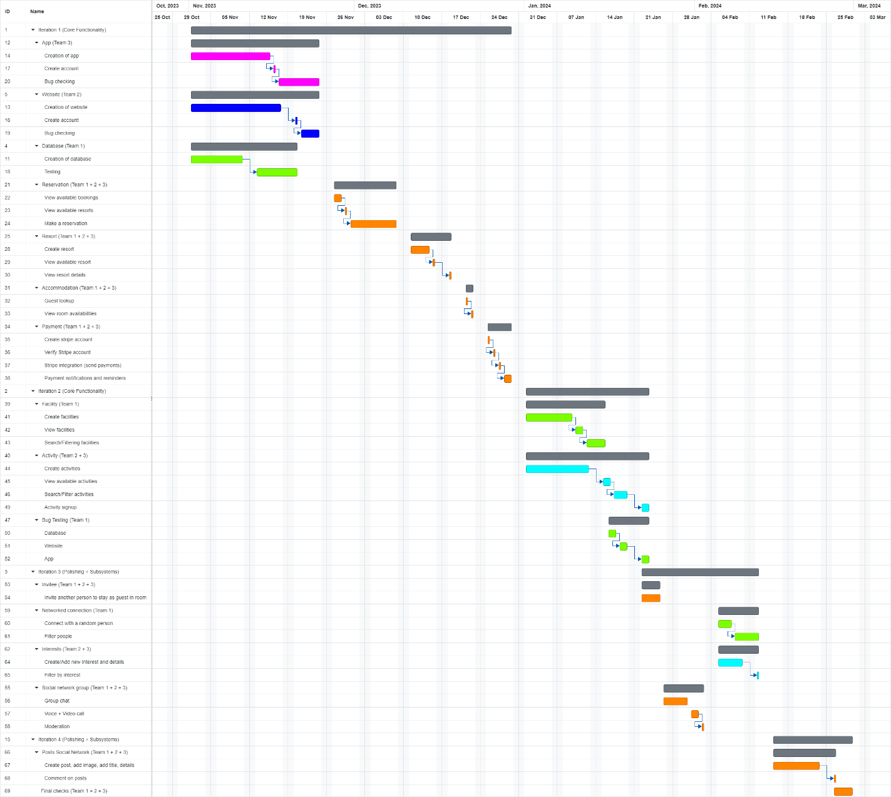

PDF: Attached separately.

.Gantt file: Attached separately.

.XLSX: Attached separately.

**Question 5 – Based on your previous answers, develop an estimate for the total project cost and the time required to complete the project.**

Estimated project cost:

Developers:

Salary ($120,000 total per project):

4 x developers

$120,000 / per developer / per year

$120,000 / 4 months total project = $30,000 per developer per project

$30,000 * 4 months = $120,000 total salary for project

Assuming junior/intermediate developers, no training required

Software:

Salary of developer

Stripe - Ongoing – 2.9% + 30c per transaction (<https://stripe.com/pricing>)

Hardware:

Cloud/yearly – Oracle - $10,000/yearly <https://www.oracle.com/cloud/costestimator.html>

$10,000 / 12 = $833 / per month

$833 * 4 months = $3,332

Office:

Working remote

$500 / per developer / month utilities + stipends

$500 * 4 developers = $2,000

$2,000 * 4 developers = $8,000 total project cost

Overall total:

$120,000 + $3,332 + $8,000 = $131,332

The total cost is $131,332 per 4 months of the project plus additional ongoing charges for Oracle (calculated 4 months server hardware cost), plus an additional Stripe ongoing charge of 2.9% + 30c per transaction.

I estimate that I could complete the initial part of the project (core functionality) within 1 month if I were doing it myself and doing it fulltime, however, it would be in an unpolished state. If I want to do this in a realistic scenario where I do not necessarily already have a database created and all of the knowledge of the project and I have 4 developers (without me working on developing it) I estimate that it could take less than a month to get a rough working example, however, if I want to be not optimistic I would say that it would take 2-3 months at maximum to get a fully working app, website, database, and payment system working, however, this is coming from an already experienced developer if it were to be 4 less-experienced developers I would estimate it would take 4 months at maximum to get at least a fully working initial mostly polished launch. With development, there is always continuation to happen and ongoing work to polish it and fix bugs, there will never not be bugs.

After completion of the project schedule/iteration/Gantt chart, the estimated amount of time is 4 months, this goes from November 1st – February 26th. All estimated start dates and end dates per individual task are also within the schedule.

**References**

Satzinger, J. W., Jackson, R. B., & Burd, S. D. (2016). Systems analysis and design in a Changing World (7e ed.). Cengage Learning.

I have neither given nor received unauthorized aid in completing this work, nor have I presented someone else's work as my own.

*Dalton Murray*